1. From the home page of your SharePoint site, in the Quick Launch click **Site Contents**.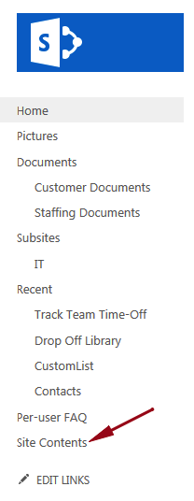

2. On the Site Contents page under Lists, Libraries, and other Apps click **add an app**.  
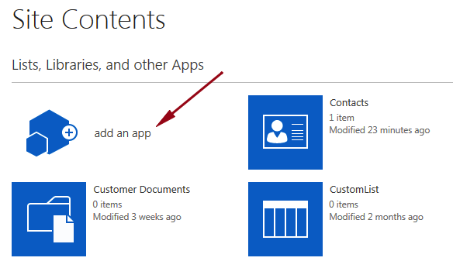

3. Under Apps you can add click **Calendar**.

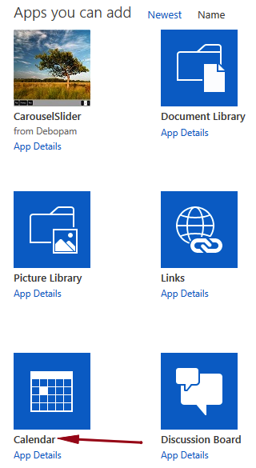

4. In the Name: section give it a name, in this example I am going to call mine “**TeamCalendar**.”  
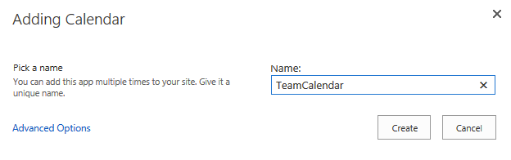

5. Click **Create**.  
  
6. Still on the Site Contents page, click TeamCalendar (or whatever you named your calendar).

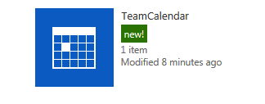

7. To create an event click **EVENTS** at the top of the page to expand the ribbon.

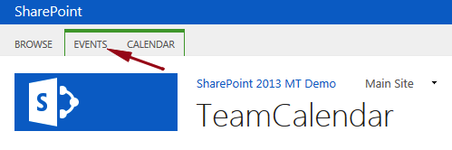

8. In the ribbon click **New Event**.  
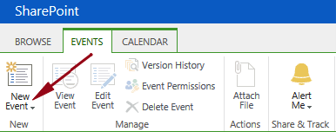

9. On the New Item window enter the following fields:

* Title – **Team Meeting**
* Start Time – **10:00am**
* End Time – **11:00am**
* Description – **Weekly update meeting**
* Category – **Meeting**
* Recurrence – **Weekly**

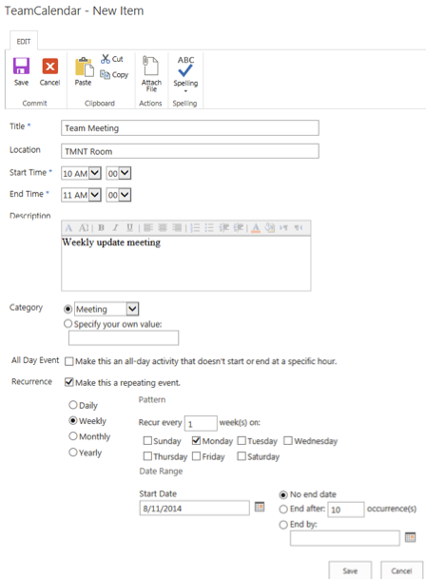

10. Click **Save**.

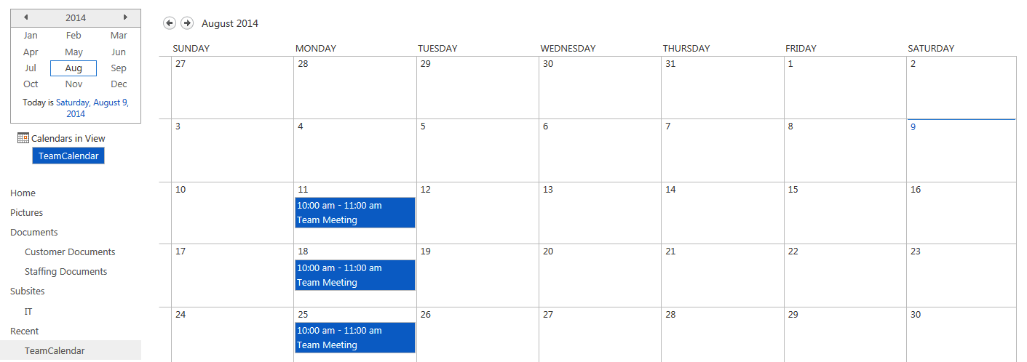

You have now created a calendar on your SharePoint 2013 site and added a weekly Team Meeting event.